3mm Titanium

Summary

Sphere Specs:
Manufacturer: Thomson Precision Ball Company, LLC

Size | Material | Grade | Gage | Actual
3 mm | Titanium | 200 | OK | +0.000380
Lot No. | Qty | Code | Scan #
100447988 | 20 Pcs | 12B | TI0118112CXXXMM

Experiment Dates: 1/28/02 – 2/8/02

Labview Time Delay: 9.00
Strobe: 12000 fpm
Scale for tracking program: 161 pixels/cm

We ran binary collision experiments with two 3mm Titanium spheres. Began from grazing positions and progressed to head-on collisions. Collisions became progressively harder to achieve with good, collectable data as we approached the head-on position. Most times the angle, α, exceeded 15 ˚ and sometimes reached as high as 80 ˚, preventing us from collecting accurate data. Louge suggested to reduce data with what we had since often the case was that there was too much data collected for head-on regime, and not enough in the grazing regime.
Ended up with 54 pictures, with two pictures taken out (26, 41) afterwards due to an error being produced by them on Pete’s program. Evaluated pictures with sphere B the faster sphere (more space between positions) and positioned on the right/on top.
After running macros program, ended up with a negative μ indicating an error in our choice for sphere labels on tracking program (“Titanium Results.xls”). After reversing coordinates for spheres A and B without negating any, reached same values for e and β, with a negated (now positive) μ (“Titanium Results2.xls”). Results from chart listed below, also see attached chart. **Note: For future data reduction, Sphere A should be used for the faster sphere that is on the right/on top in the resulting images. Sphere A2 should be more to the left than sphere B2.
Two sets of results were obtained. Partway through this semester it was realized that in one of the data reduction spreadsheets, “coefficient calc-binary.xls”, one value for π was not consistently used. In some places, 3.14159 was used and in others 3.1415. To correct this error, since small errors could potentially lead to greater errors, anywhere where a calculation used the value of π, we entered π as a function (i.e. “pi()”) which would use the full value of π in the calculation. After correcting this error, the data was reduced a second time and no significant changes occurred in resulting values for the properties. However, there were small changes in the actual numbers for values such as ψ₁.
When reducing the data, we removed one point that was in the sliding regime, yet appeared to be an outlier and far from the general trend. The outlying point can be seen in the “Titanium Results.xls” included below, however the point was removed in the “Titanium Results2.xls” and “Titanium Results2 pi.xls” graphs pictured below. Removing that one point changed the results by very little. However, we felt that the data was more reliable without that outlying point.

Results with outlier
e | β_{o} | μ
0.91 +/-0.03 | 0.48 +/- 0.17 | 0.10 +/-0.01

First Results (w/correct μ )
e | β_{o} | μ
0.92 +/-0.01 | 0.48 +/- 0.17 | 0.10 +/-0.00

Second Results – with pi correction
e | β_{o} | μ
0.92 +/-0.01 | 0.48 +/- 0.17 | 0.10 +/-0.00

The effective e, e’ where e’ = e – (π/2)*μ, for Titanium was about 0.753. Ideally for our experiments, we’d prefer e’ > 0.7, making Titanium a possible replacement of Nitinol. However, more experiments against different materials and object still need to be conducted before coming to a final conclusion.
Louge finds the results promising, since Titanium (4.5 g/cm³) is lighter/less dense than Nitinol (6.71 g/cm³). Titanium may be more easily attainable and also less expensive. Tests still to be run with Titanium: binary (Titanium/Ceramic), plate collision (glass window), plate collision (300 Series Stainlesss), & bump collision (300 Series Stainless).

Images

 | 
Extreme grazing  Picture No: 01 | Grazing  Picture No: 30
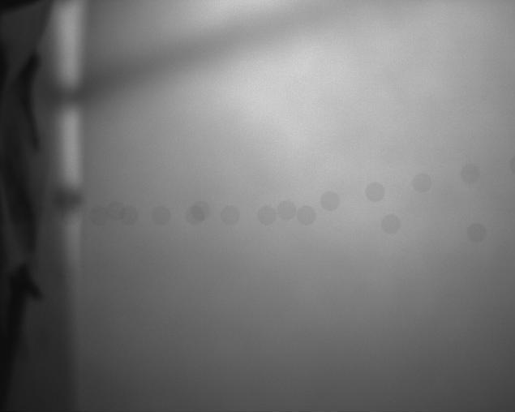 | 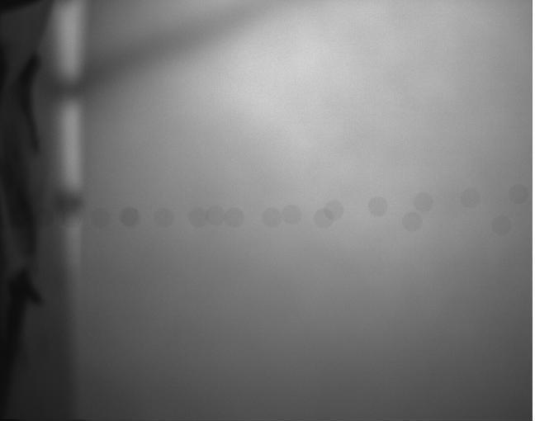
Collision  Picture No: 50 | Head-on collision  Picture No: 52

Results

“Titanium Results.xls”
(negative μ)

“Titanium Results2.xls”

“Titanium Results2 pi.xls”

